1655 Divisadero
San Francisco, CA 94115
$85,000 (PENDING bus)

(The above information is deemed reliable but is not guaranteed)

Features
- Rent only $2,500
- Fully Equipped Kitchen
- ADA toilet :Yes
- Next to CPMC Mt. Zion Hospital
- New Construction Nearly, More Employee, Growing Area
- Easy to manage By 1-2 staff (even PT)

 | For further information, please contact:  Francis Ha 夏學理  Broker Associate  Lic # 01798336  Cell: 415-517-1034  Francis@kkandc.com

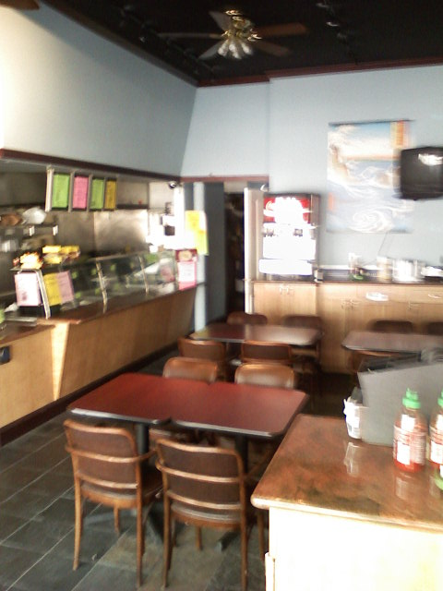

GREAT OPPORTUNITY . 大機會。

BE YOUR OWN BOSS. 自己做老闆。

LOWEST PRICE NOW現在最低價格


